**Case Study:**

**Advantages of Using AI in Government and Public Sector**

**R.Y – ITAI 2372**

**Introduction**

AI has expanded vastly and began to show up in many different industries. Many AI tools have been dedicated for media and chat generation, able to generate art, ideas, code, and various assets creators could use for making what they want. Outside of personal use though, AI has also shown it’s influence on business and government industries with systems like AI fraud detection for finance, or public health through automated routes for cleanup, recycling and even security.

Although the implementation of AI has many positive impacts on these industries, making services more efficient, automated and sometimes cheaper, or just reducing the need for labor, it has its downsides. People fear that AI will eventually fully replace them in their jobs, collecting more personal information about them, and removing the human aspect of every process. In this study, I’ll be specifically covering AI use in the government, and public service and how it’s impacted both areas in a positive and negative way.

**Use Cases/Tools Used**

**Government:**

AI Companies and developers have begun creating AI specialized for tasks that government organizers/community managers and are advertised towards them. One of these companies is “Polco”, offering a multi-agent framework that helps with Budgeting, Strategic Planning, Data and Insights, Grant Writing, and Organizational Culture. These agents are trained in community and public data to make smart improvements or recommendations for officials to use.

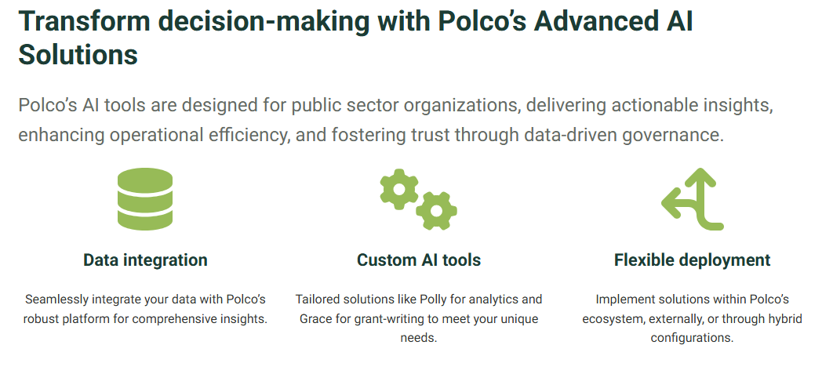

[**AI | Polco**](https://info.polco.us/platform/ai?utm_id=22339958837&utm_campaign=Polco-AI-Solutions&utm_source=google&utm_medium=paid-search&gad_source=1&gclid=EAIaIQobChMIgofS9JLCjAMVjSfUAR09PC30EAAYASAAEgJpSPD_BwE)

**Public Health:**

For public health, many AI services have provided overall public health through things like recycling services, and also individual services by being implemented into healthcare networks. Recycling services are able to take geographic data, utilizing knowledge of high waste areas to automatically perform routes efficient for picking up waste. When collecting the waste, AI can also use vision and labels to automatically sort types of trash such as recyclable plastic, ceramic, metal, or other types that are picked up.

[From Trash to Cash: How AI and Machine Learning Can Help Make Recycling Less Expensive for Local Governments | NIST](https://www.nist.gov/blogs/taking-measure/trash-cash-how-ai-and-machine-learning-can-help-make-recycling-less-expensive)

Healthcare AI is commonly used for things like medical imaging, and records since it’s able to instantly read and identify abnormalities as well as automatically diagnose them on the spot. Referencing and reading medical records can take lots of time for human workers, or having to have prior experience to remember what diagnosis needs and what treatment. AI not only diagnoses the issues but is also able to sort through personalized treatments based on medical data and profiles for different patients.

**Public Safety:**

As for public safety, AI can use similar systems that it’s done for recycling to identify high crime areas, times, and other patterns to enforce predictive policing in high-risk areas. Businesses can also protect the public through services like fraud detection, picking up abnormalities in spending habits, locations, or amounts/frequency to find anomalies and stop the payments.

**Outcome/Benefits**

**Government:**

One of the major benefits of utilizing AI for managing government or community tasks is the ease of workload. AI is able to instantly analyze records and data given, identify issues people have given, and give recommendations to address and connect with the community to improve them. This saves officials time and strain, as well as addressing issues quicker than they normally would, which satisfies the public faster.

**Public Health:**

Recycling services benefit greatly from AI, not only are they able to get efficient routes to spend less time-wasting fuel for trucks, they also reduce the risk of improperly sorted waste. If normal trash is sent to a recycling plant, it may cause issues with the systems or potentially damage or create hazards for improper waste disposal. This cleans up the community in a faster more efficient way and improves the public’s health by guaranteeing safe disposal.

For healthcare systems, thousands of records have to be sorted and manually gone through or found for individual profiles. AI is able to sort these records instantly, reference them when needed, and find specific files that staff may be looking for. Models are also able to reference these records in medical imaging, to give faster and more accurate diagnosis, as well as customized treatment plans to better the overall health of the community.

**Public Safety:**

Predictive policing can have officers ready and on standby for high crime areas and potentially respond or prevent crimes faster than they normally would. This also can save patrol time, and resources as fewer active areas won’t need as much monitoring, and high crime areas can become safer.

Fraud Detection helps not only save people money and expenses but also build trust with banks and financial institutions more. With increased personal records, fraud is able to be identified on an individual basis from personalized profiles, increasing accuracy and helping secure a customer’s funds. This makes people less vulnerable to scams, and help identify and prevent scams they might fall for in the future.

**Challenges/Problems**

AI doesn’t come without drawbacks though, as many systems aren’t perfect and have to be updated to make sure they’re accurate and working. The general public may not always be confident in their governments, health, and finances being managed by machine models as well.

**Overreliance:**

As more AI systems are integrated into more areas, they become more and more dependent on proper infrastructure and maintenance. This brings up the risk of bringing entire industries and systems down when the Ai fails to work or breaks. Government systems running on AI may give improper or delayed responses to issues, with officials unprepared to handle them from lack of research. Another scenario could be healthcare, or fraud services going down leaving doctors or bankers totally blind to being able to support patients/customers in times of need. When AI is taken at face value as well, possible errors such as misdiagnosis, or improper functionality without human double checking could lead to easily preventable problems.

Lastly, overreliance of AI can cause major issues with just the population, the people may not like that their issues and messages to officials are just sent and resolves by AI, as they lose personal connections with their officials. Mistrust of how their data is handled by AI is also an issue, as many people could prefer a human doctor and diagnosis, rather than having a machine model in control of their life, and finances.

**Job Displacement:**

As AI gets better, it is cheaper to manage, and more efficient at jobs people become less and less relevant in a workplace. Taking potential jobs from people, where they could have proper wages and living and giving it to a machine model becomes a bigger issue as soon as AI begins to evolve. People’s education in a certain field could be useless, or they’d be forced to pay for higher education to get jobs that AI hasn’t fulfilled.

**Complexity:**

AI Integration and infrastructure can be complex, and expensive, meaning it’s a big investment to implement. Hospitals, Banks, or Government programs may have to be entirely re-structured to accommodate AI, which can improve the previous issue of overreliance, and job displacement.

**Bias:**

AI Models are trained off data, and created by people, leaving it open to specific biases coming from either source. Bias in models within important industries like government, and health can be dangerous as improper and biased solutions may be applied to issues, or improper data can lead to healthcare models giving a misdiagnosis.

**Innovative Proposal**

**Issue:**

One issue that still plagues many populated or busy cities is traffic delays, and the impatience from red lights causing accidents. Considering most modern traffic systems are on a specific schedule, having to be manually rerouted in certain circumstances, further delays and time is wasted at a red light, increasing not only the time people waste on the road, but the emissions and fuel spent from cars just waiting to move. Studies show that around 10% of total delay time, and over 10 million hours are spent waiting at improperly timed lights in America every day.

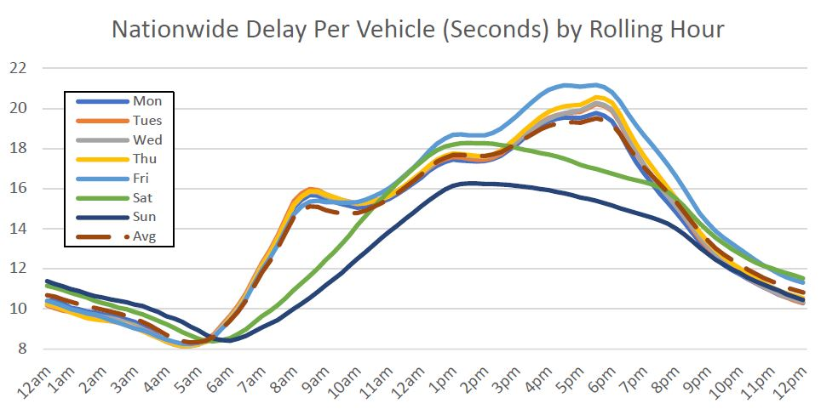

[Time gets wasted at traffic signals; report explores how much - Land Line](https://landline.media/report-reveals-how-much-time-is-being-wasted-at-traffic-signals/)

**Proposal:**

The proposal I came up with is an AI powered system for traffic management, using common travel trends, imaging, and predictive route analysis to automatically change a traffic light for less wasted lights. This allows light-traffic days and lightly populated routes become way less stressful and timesaving, while heavy traffic days can alternate and better control traffic flows. This can also automatically adjust instantly to any accidents, or light faults which usually take time and manual intervention to reroute, or cause dangerous situations where cars are stuck at an unlit intersection.

**Reasoning:**

The reasons I believe AI should be used for traffic management are that it’s better for the environment, people’s daily commute, and even increase their safety. Less time on the road for drivers means less idle time and overall, less time with their engines running, reducing carbon emissions on the road. With better efficiency, they’ll also be able to get from point A to point B faster, not only allowing workers to get where they need, but responders can also get to emergency situations faster. With decreased travel times too, drivers may be less likely to need a distraction, or get impatient and run a red light which can cause fatal accidents or severe damage.

**Expected Outcome:**

I expect these new lights to create way more reliable transport, even maybe branching into a path where people may chart their routes on an app ahead of time, allowing even better timing and tracking to be done which will make the AI even more helpful. I also expect this to reduce traffic accidents and fatalities overall as people are made more aware that every delay is for a reason, rather than just improper timing.

**Potential Challenges:**

One of the challenges I find is that it will take tons of resources and change to set up route cameras and data collection. Almost every street will need to be taken into consideration to account for accidents, delays, or clear routes that could have green lights. Leaving it up to an AI system also means that bias, or improper timing could lead to more accidents rather than the consistent traffic lights which don’t share the same issue.

**Conclusion**

In conclusion, I think that the main benefits of AI stem from their efficient analysis, and quick responses that humans can’t compare to. This makes models and agents great for situations where these are needed, such as analysis of community problems for an official, or even a quick diagnosis for a doctor. Although relying only on AI causes the potential issue of any bias, or errors that could be prevented slipping through, as well as a disconnect from people in general that you’re trying to help with models designed for fixing problems. AI model use needs to be carefully used, and not immediately introduced into every environment, as the sudden change can cause more problems, rather than solutions.

**References**

**A01 – A08 Canvas Notes**

**“AI.” *Polco*, info.polco.us/platform/ai?utm_id=22339958837&utm_campaign=Polco-AI-Solutions&utm_source=google&utm_medium=paid-search&gad_source=1&gclid=EAIaIQobChMIgofS9JLCjAMVjSfUAR09PC30EAAYASAAEgJpSPD_BwE. Accessed 3 Apr. 2025.**

**Sutliff, Bradley. “From Trash to Cash: How Ai and Machine Learning Can Help Make Recycling Less Expensive for Local Governments.” NIST, Bradley Sutliff, 30 Jan. 2025,** [**www.nist.gov/blogs/taking-measure/trash-cash-how-ai-and-machine-learning-can-help-make-recycling-less-expensive**](http://www.nist.gov/blogs/taking-measure/trash-cash-how-ai-and-machine-learning-can-help-make-recycling-less-expensive)**. (+ A05 Notes)**

**“Artificial Intelligence (AI) in Healthcare & Medical Field.” *ForeSee Medical*, www.foreseemed.com/artificial-intelligence-in-healthcare#:~:text=The%20Benefits%20of%20AI%20in%20Healthcare&text=AI%20for%20healthcare%20offers%20the,predicting%20outcomes%2C%20and%20recommending%20treatments. Accessed 4 Apr. 2025. (+ A03 Notes)**

[**https://highways.dot.gov/media/11401#:~:text=the%20signal%20violators%20%E2%80%94%20they%20are,motorists%2C%20pedestrians%2C%20and%20cyclists.&text=red%20light%20is%20unacceptable%2C%20yet,in%20the%20past%2030%20days.&text=1%2C000%20injury%20crashes%20EVERY%20DAY%20at%20signalized%20intersections%20across%20the%20United%20States**](https://highways.dot.gov/media/11401#:~:text=the%20signal%20violators%20%E2%80%94%20they%20are,motorists%2C%20pedestrians%2C%20and%20cyclists.&text=red%20light%20is%20unacceptable%2C%20yet,in%20the%20past%2030%20days.&text=1%2C000%20injury%20crashes%20EVERY%20DAY%20at%20signalized%20intersections%20across%20the%20United%20States)**.**

**Fisher, Tyson. “Time Gets Wasted at Traffic Signals; Report Explores How Much.” *Land Line*, 12 Mar. 2021, landline.media/report-reveals-how-much-time-is-being-wasted-at-traffic-signals/.**

**Johnston, Ryan. “Poorly Timed Traffic Signals Are an Even Bigger Time Waster than Previously Thought, Report Finds.” *StateScoop*, 24 Feb. 2021, statescoop.com/inrix-traffic-signals-traffic-congestion-research-2021/.**